Enigma Astrology Research 0.1

User Manual

April 25, 2023

Enigma Astrology Research

Thank you for your interest in Enigma. You are about to learn more about a program that calculates charts and also supports several types of research into astrology.

You can use it for your astrological calculations. Enigma is accurate and calculates fast. It will produce a chart wheel and perform the most important analysis.

The program also supports several types of research: counting aspects, occupied midpoints and more. And it generates control groups so that you can cancel out artifacts.

Several other releases will follow the current release 0.1 and each new release will add more functionality.

Enigma is free: you do not have to pay for it. And Enigma is open source: I published all code, and anybody can download it. Programmers that want to use my code can do so freely, but only if their own software is also open source.

I hope you enjoy the program!

Jan Kampherbeek,
Enschede, The Netherlands, April 25, 2023.

Parts of the user manual

This User Manual comprises the following parts:

- Installation. Learn about the technical requirements and how to install Enigma.
- Configuration and settings. You can tailor Enigma to your own preferences.
- Charts. How to calculate and analyze a chart.
- Research. How to set up and perform research.
- Appendix. Specifications and background information.

Installation

Requirements
You need a computer that runs Windows. I have tested Enigma on Windows 11, it probably runs on older versions, but not older than Windows 7. Enigma will probably run in a Windows emulator on Apple hardware, but I did not test that.
The program requires about 150 mb disk space and about 4 GB internal memory.
Preferably, use a full HD screen or larger.

Installation
Download the installation program from https://radixpro.com/enigma. You will receive a file enigma_ar_install.exe which you can save anywhere on your computer.
Double-click this file to start the installation.

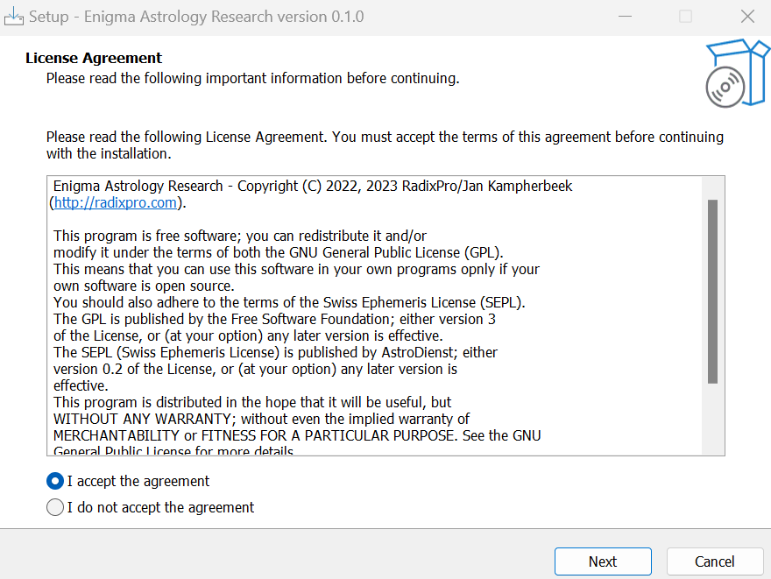
Enigma shows a license which you should accept to continue. Select I accept the agreement and click the button Next.

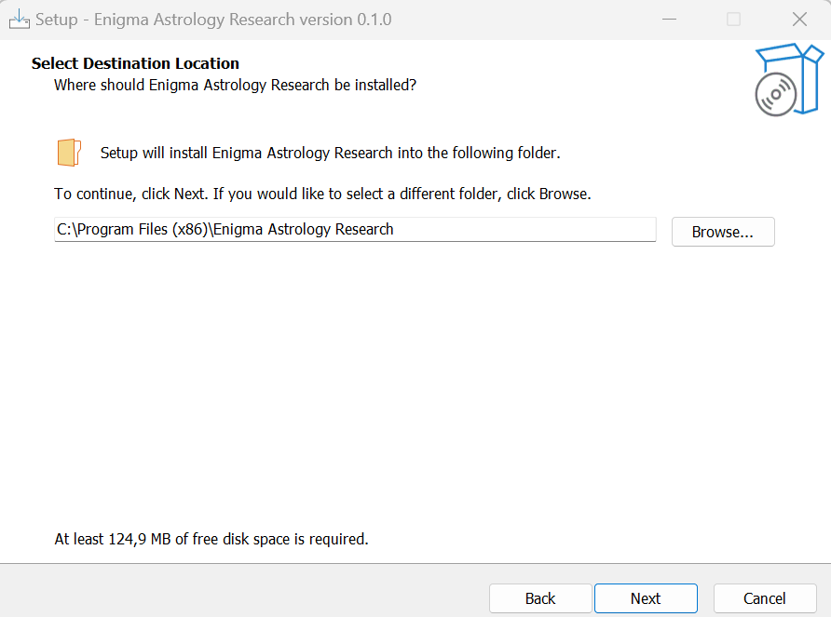

On this window, you can select the folder where you want to install Enigma. I advise to use the default location.
Click the button Next.

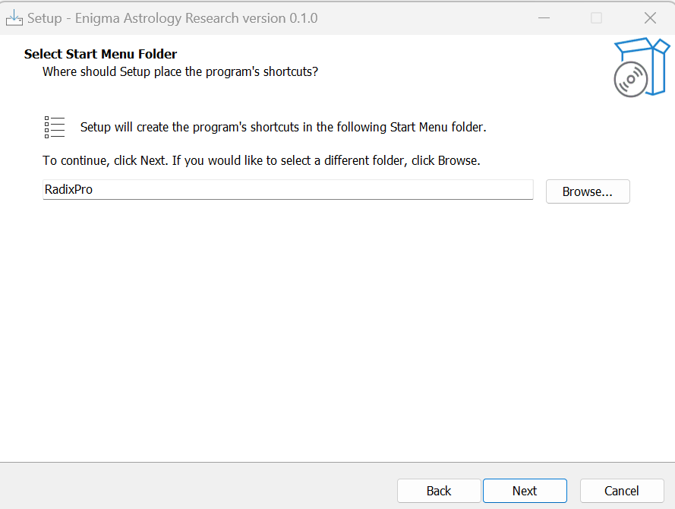
Enigma uses RadixPro as the start menu folder, but you can change this if you prefer another folder.
Click the button Next.

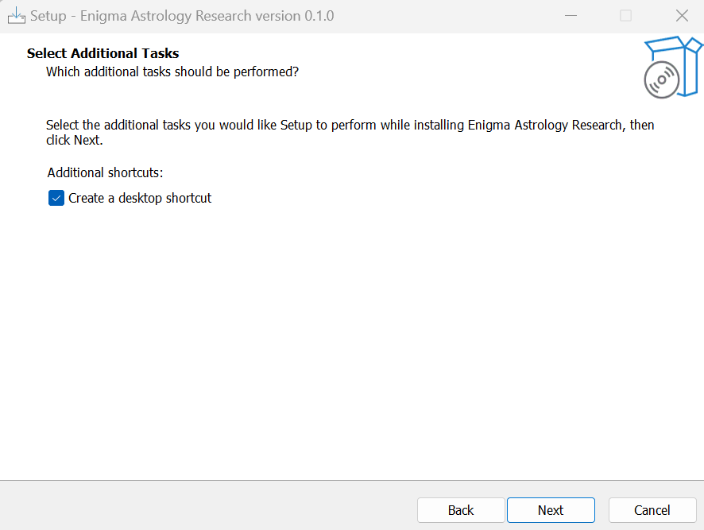
If you select the checkbox Create a desktop shortcut, the installer will create an icon on your desktop to start Enigma.
Click the button Next.

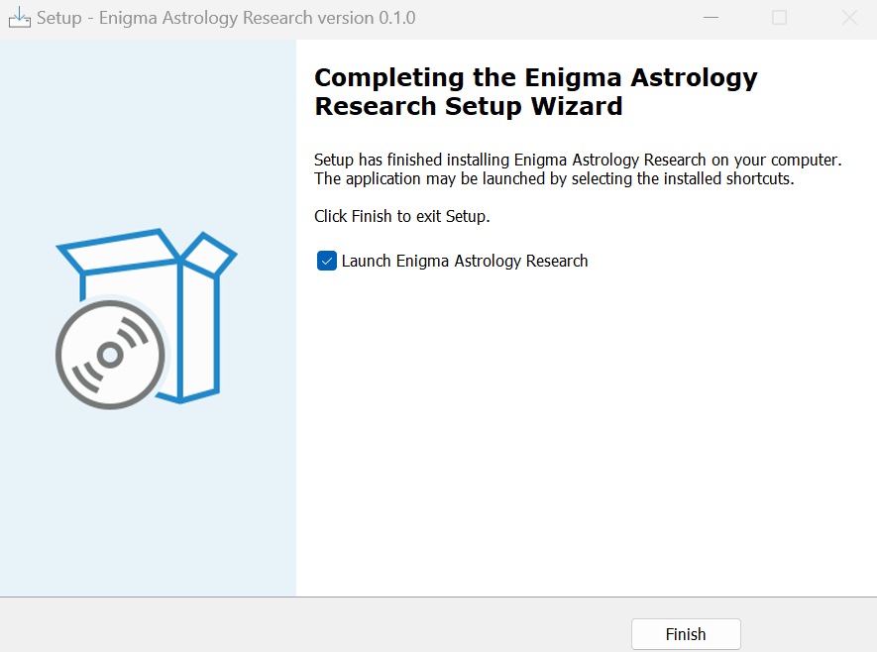
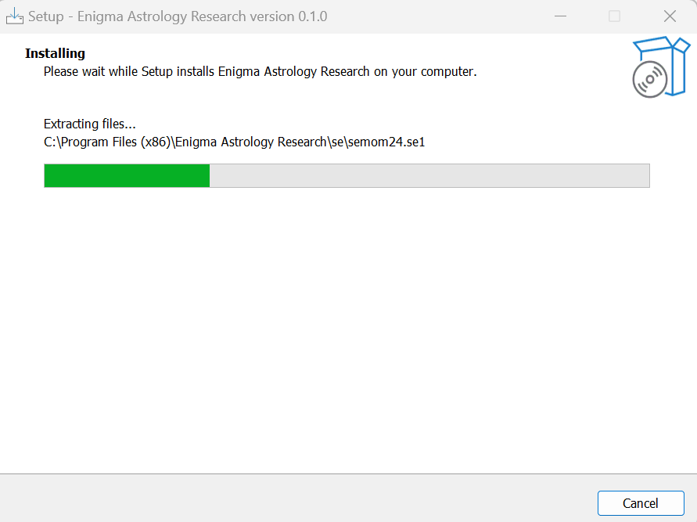
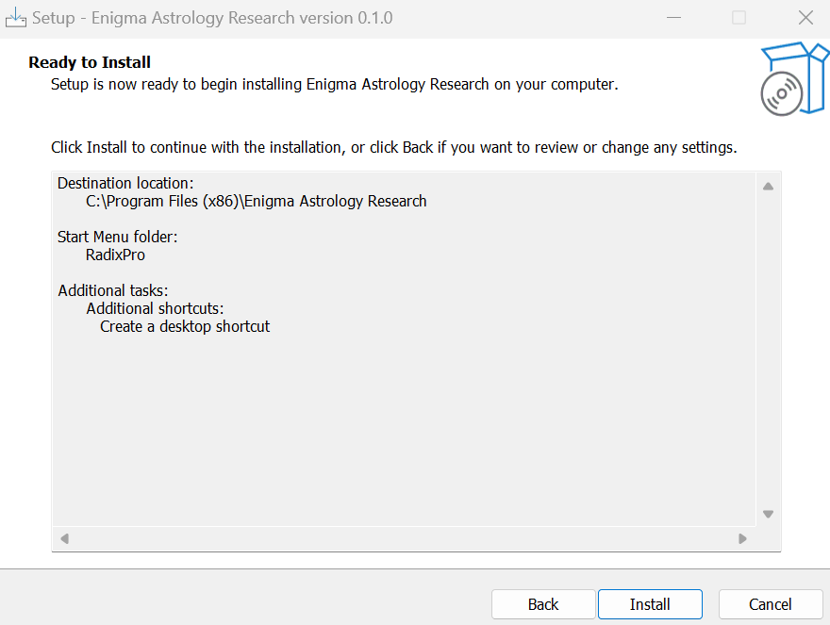
Review your selections and click the button Install.

You will see a progress bar during installation.

If you see this window, the installer completed its task. Optionally, select the checkbox Launch Enigma Astrology Research to start Enigma.
Click the button Finish.

The installer made the following changes to your system:
- It installed Enigma in C:\Program Files (x86)\Enigma Astrology Research. This folder also contains a sub-folder se with the required files from the Swiss Ephemeris.
- The file User Manual Enigma Research - 0.1.pdf is in the same location.
- The font EnigmaAstrology is now available. You can use this font also in other applications. For more information, check http://radixpro.com/downloads/font/

Enigma used the folder c:/enigma_ar and its sub-folders. After starting Enigma, these folders are created automatically.

Removing Enigma

It is easy to remove Enigma. In the settings of Windows, you can select an overview of installed apps. Search for Enigma Astrology Research and remove it.

Updating Enigma

Each time you start Enigma, it will check if a new version is available. It will perform this check only if it can find a connection to the Internet.
Enigma will inform you of any new release and show a link to download and install it. You can always install without removing the previous release, provided you do not change the location of the installed application.

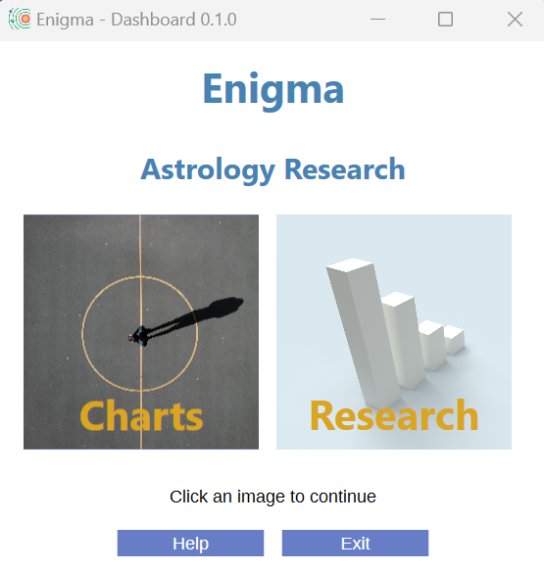
General

Starting Enigma

Click the Enigma icon to start the program.

You will see a window with two images, one labeled Charts and one labeled Research.

Click an image to go to the corresponding module. If you finish working in a module, you will return to this start window and can make another selection.

Both modules of Enigma use the same configuration and the same settings.
The settings define the location of files that Enigma uses. The configuration gives you the opportunity to define how Enigma behaves astrologically: which house system, which planets, aspects, and much more.

Settings

You can access Settings from both modules Charts and Research and check them, but in this release of Enigma, you can not change anything.
Select the menu option General - Settings. You will see a window with information about the location of the following files:

- Data files. This folder contains the data files you imported.
- The location of Projects. All projects will have a sub folder with the name of the project. These sub folders contain all data that is generated for this project.
- Enigma does not yet use Exported files. In the future, it will contain the results of exporting data.
- Enigma writes remarks to Log files. In case of an error, these log files will be helpful.
- The folder Database contains data for calculated charts.

Configuration

You can check and change the configuration via the module Charts or via the module Research by selecting the menu option General - Configuration.

This will show a window with a wide range of configurable items. The window comprises 5 tabs:
- The tab General shows astronomical settings and settings for orbs.
- Celestial points shows the most common planets and some other points.
- Minor/mathematical shows Plutoids, Planetoids, Centaurs and mathematical points like nodes.
- Hypothetical shows hypothetical planets.
- Aspects show all available aspects.

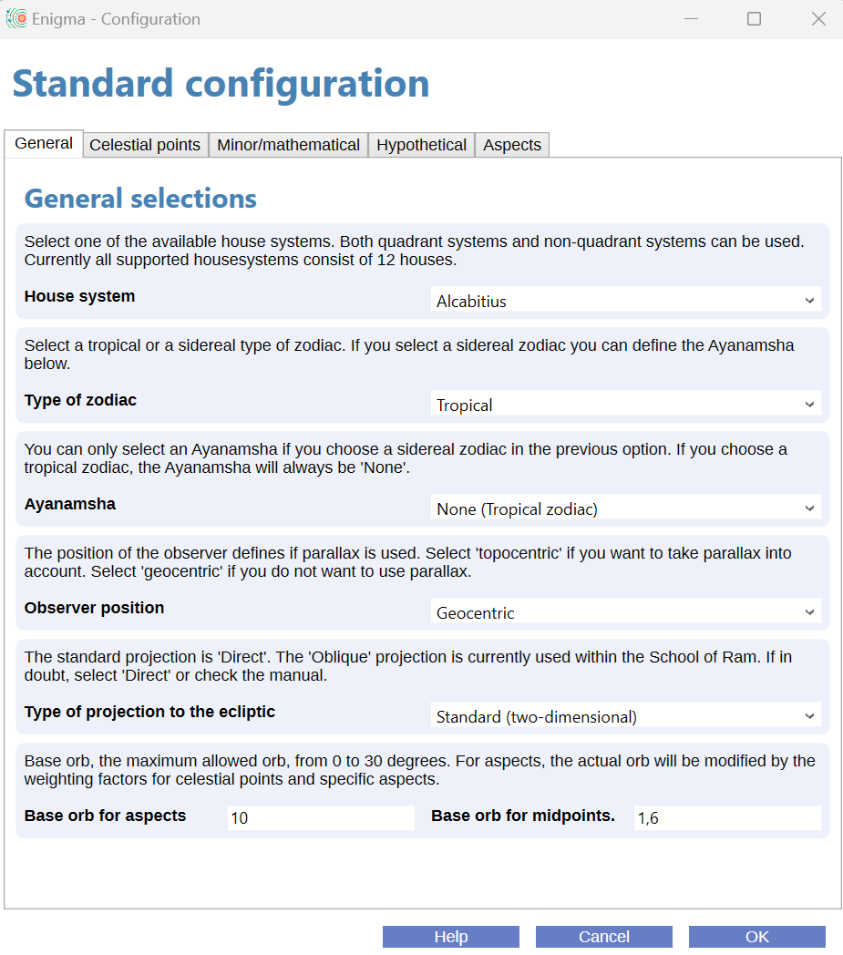

General selections
If you select the tab General you can define the following preferences:
House system. Currently, Enigma supports only house systems with 12 houses. Select None if you do not want to use a house system.
Type of zodiac. Select either sidereal or tropical. If you select tropical, the Ayanamsha will always be None. If you select another Ayanamsha, the setting for Type of zodiac will automatically change into sidereal.
Ayanamsha. Select one of the available Ayanamshas. In the paragraph Appendix: Ayanamshas you will find a brief explanation of the different possibilities. See also the remarks at the point above: Type of zodiac.
Observer position. The standard approach is geocentric, if you want to take parallax into account select topocentric. The option heliocentric is for heliocentric charts.
Type of projection to the ecliptic. Select Standard (two-dimensional) for most approaches. Oblique longitude provides an alternative calculation as supported by the School of Ram. It is also called True Astrological Longitude Location.
Base orbs. You can define orbs for aspects and for midpoints.
The base orb for aspects will be corrected with the percentages for celestial bodies and aspects. See the paragraph Appendix: Defining orbs. The value shows the maximum orb for the most important aspect and the most important celestial body.
The Base orb for midpoints is the effective orb for midpoints.

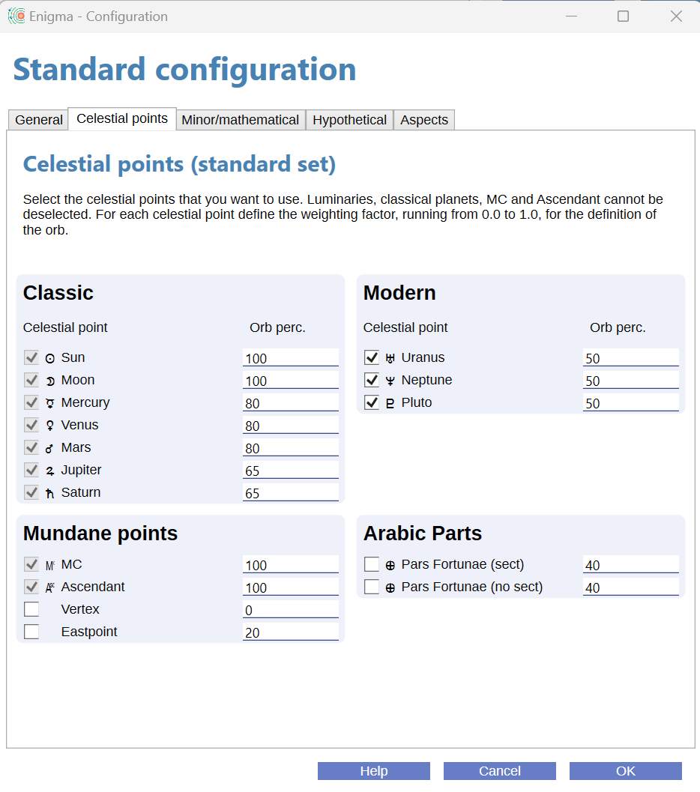

Celestial points
The tab Celestial points is the first of three tabs where you can define points for your chart.
For each point you will find a checkbox. Check this box if you want to take the celestial point into account, deselect it if you do not want to use it.
There is also a value Orb perc. (Orb percentage) that you can change. You can enter a percentage from 0 up to 100, make sure you use only whole numbers. It is possible to define a percentage for a point that is not selected, so it is easy to remember a percentage if you later decide to include the point. If you want to use a point but not calculate aspects for that point, enter a percentage of zero.
In this tab you see four types of points: Classic, Modern, Mundane points and Arabic Parts. Please note that you cannot deselect the classic points and also not MC or Ascendant.
See the paragraph Appendix: Planets and other celestial points for more information.

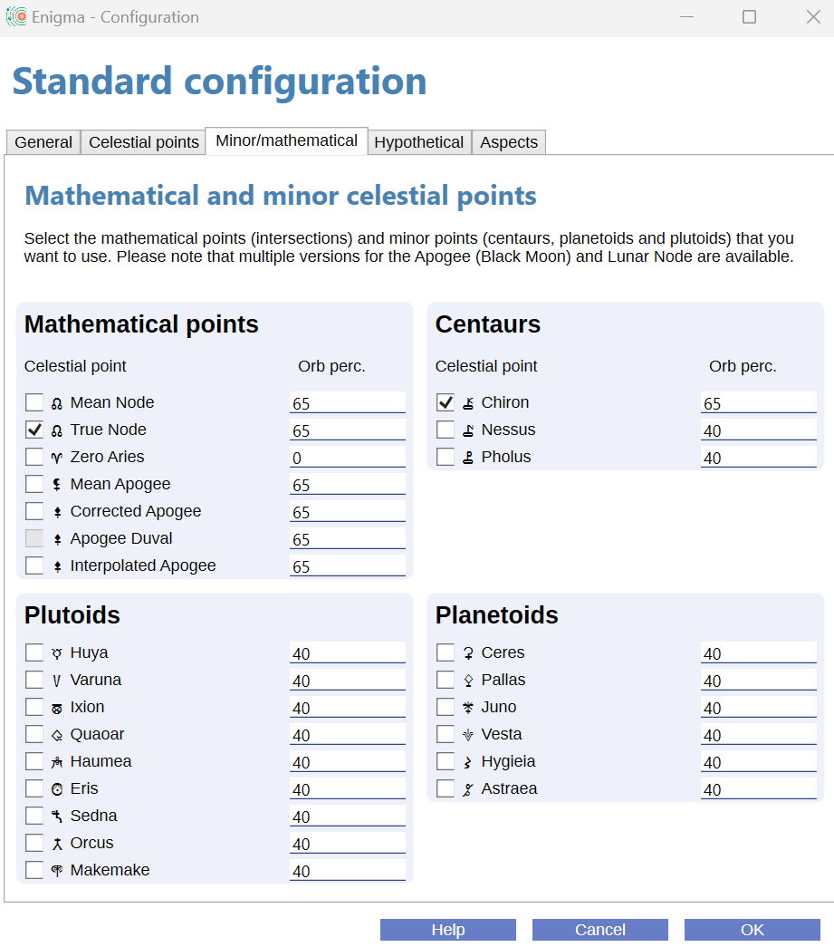

Minor/Mathematical
The tab Minor/Mathematical contains four types of points: Mathematical points (mostly intersections), Centaurs, Plutoids and Planetoids.
Use it the same way as described for the tab Celestial Points.

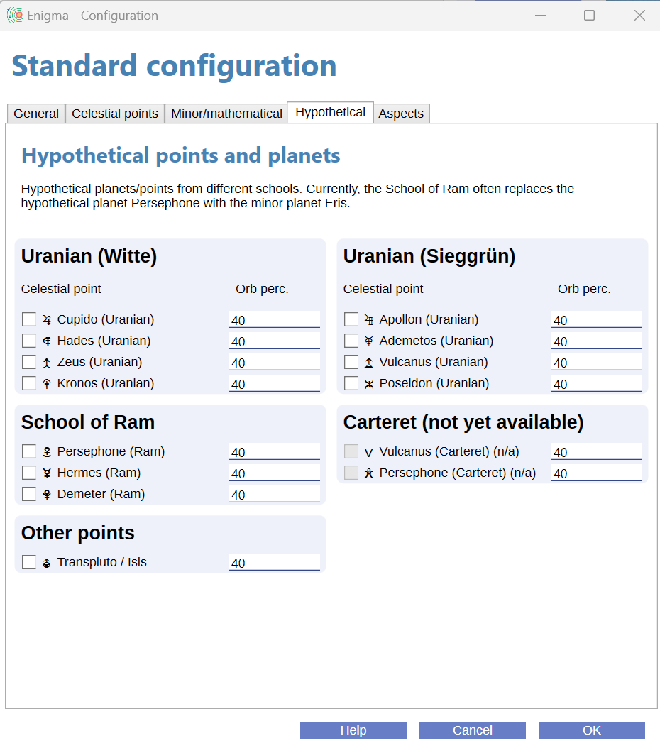

Hypothetical points and planets
The tab Hypothetical enables selections of different types of hypothetical points/planets.
Use it the same way as described for the tab Celestial Points.

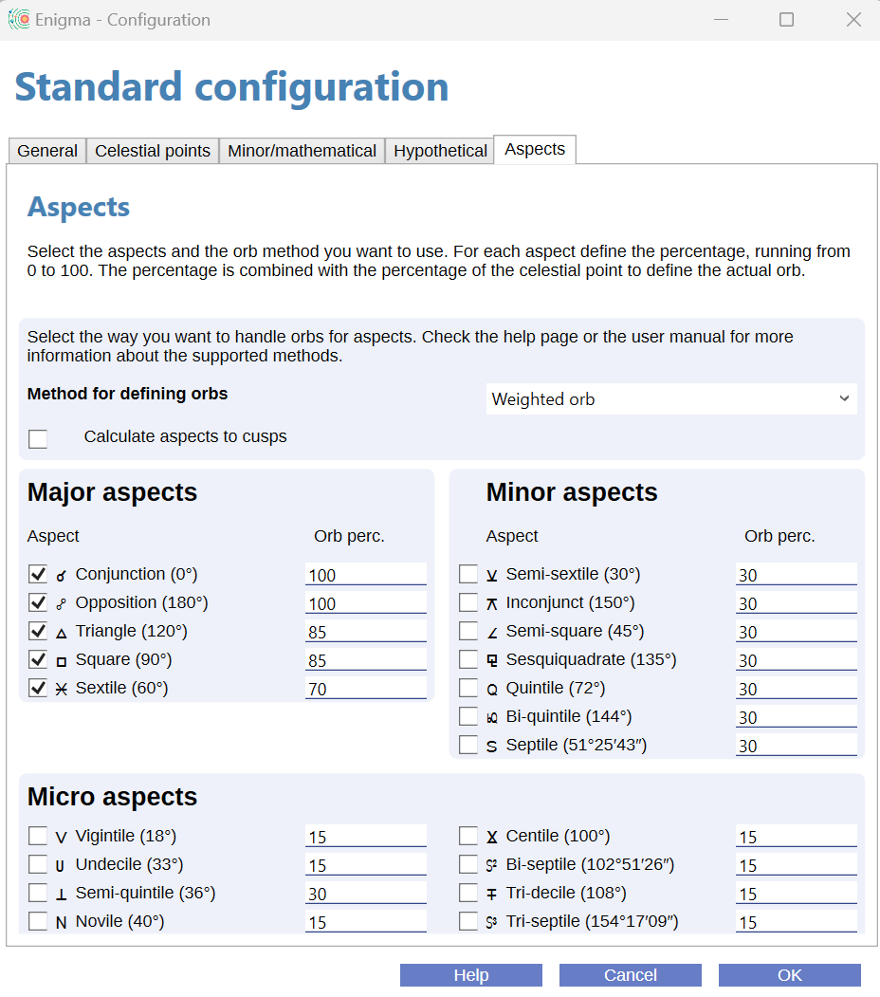

Aspects
Aspects is the last tab for the configuration. In the current release, there is only one method to define orbs: Weighted orb. It uses percentages for celestial bodies and for aspects to define the actual orb.
See the paragraph Appendix: Defining orbs for more information.
Enigma divides the aspects into three categories: Major, Minor and Micro. For each aspect you (de)select it, using the checkbox, and define the percentage for the orb.

User assistance

Enigma tries to help you when using the program. It shows on-line help, checks your input, writes details to a log-file and prevents wrong results.

On-line help

In almost all windows, Enigma shows a button Help. If you click this button, the program shows specific information for the current window.
To prevent cluttering the screen with many windows, you need to close the help window before you can continue.

Input check

Where possible, Enigma checks your input. It checks for the correct format and range for date, time and geographical coordinates. It also checks if a date is valid and it takes leap years into account while doing so.
If you make an error, Enigma marks the entry with a yellow background color after clicking the button OK. Just correct the input and click again.

Please note that you enter numbers with fractions based on the ‘locality’ (language and other settings) of your computer. If you normally use a dot to separate integer and fraction, you also need to use a dot in Enigma. The same if your computer default expects a comma.

Log-files

Enigma writes information about its activities to log-files. These files are in the folder c:\enigma_ar\logs. Each day, the program starts a new log. If there are more than 31 log-files, the program deletes the oldest files. In case of an error, the log-files can contain important information about the error. I might ask you for these log-files if you report an error.

Preventing wrong results

Enigma supports almost 30000 years of planetary calculations. But for some celestial points, this period is much shorter. Especially for Chiron, which you cannot calculate before 675 CE.
The Swiss Ephemeris, which takes care of all the calculations in Enigma, does not object if a planet is out of the supported range, it just returns a zero. This translates to zero Aries, and you could happily use this point and calculate aspects and midpoints. That makes little sense, so Enigma filters the results: if it cannot calculate a celestial point, it will just omit it.

Charts

In the Charts module, you can calculate and analyze charts. You can also save and retrieve charts from a database.
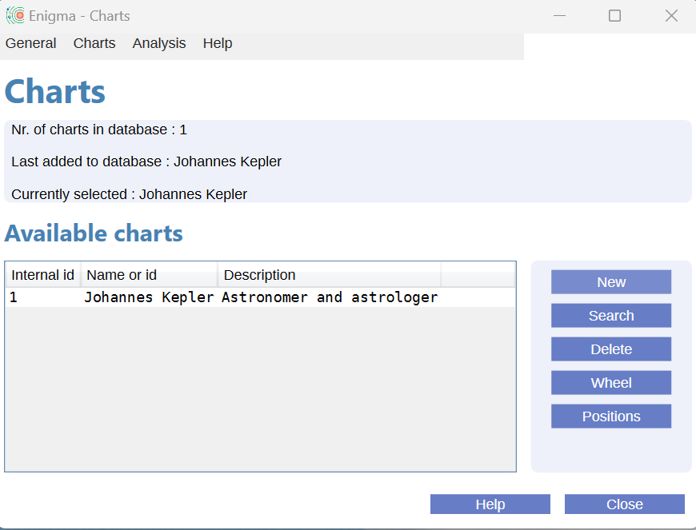
If you select the Charts module, Enigma shows a window as show left. It mentions the number of charts in the database, the file that was last added, and also the currently selected chart. Under Available charts, you see all charts that you calculated or retrieved from the database. Enigma clears this list if you close the window or after you change the configuration.
With the buttons alongside the overview of charts, you can perform the most important actions. You can access other actions via the menu.

Handling multiple windows

You can open multiple windows. It is possible to compare different charts but you can also compare the results of the same chart with different settings.
If you calculated, or retrieved, a chart and opened windows to analyze it, these windows will remain available if you change the configuration, for instance, to select a different house system. After changing the configuration, select the chart again from the database and show the new results in a new window.

Calculation

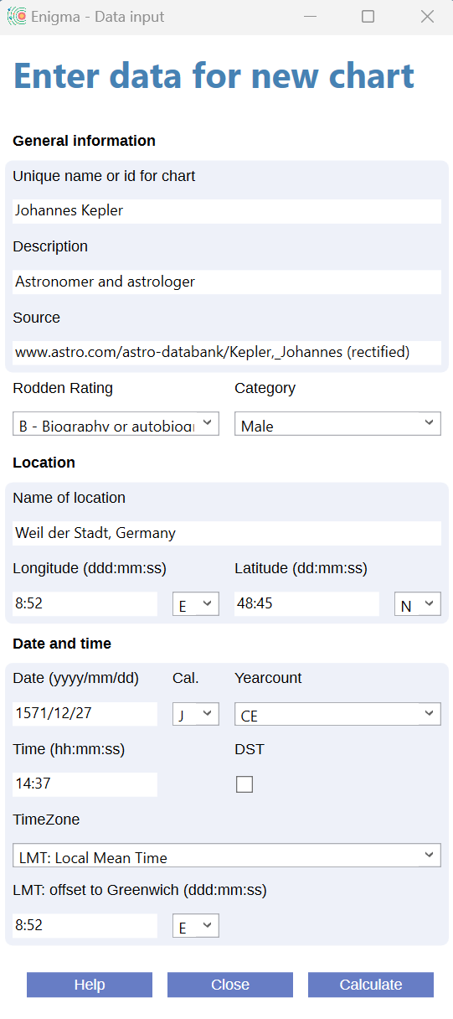
To calculate a chart, click the button New or select the menu-item Charts - New Chart.

In this window you will see three blocks:
- General information is for data that is not required for the calculation but is used to identify a chart.
- Location is for name and coordinates of the location.
- Date and time is for all information about the date and birth-time or event-time.

General information
Unique name or id for chart. Enter an identification for this chart. This can be a name, a number or some other identification. It is possible to enter the same name multiple times. If you search for charts, Enigma automatically prefixes the names with a unique number. The program uses ‘Anonymous’ if you do not enter a name.
Description. An optional description for the chart.
Source. A brief and optional explanation of the source of the data.
Rodden Rating. Select one of the Rodden Ratings or leave the default value Unknown.
Category. Select the subject for which you calculate this chart or leave the default value Unknown.

Location
Name of location. A city name, address or other identification for the location. This field is optional.
Longitude. Geographic longitude in the format ddd:mm:ss. For 123°45'30" you need to enter 123:45:30. You can skip the seconds, they will default to 0 seconds. So 145:15 is a valid indication for 145°15'00".
Use the scroll-downbox to select either E (East) or W (West).
Latitude. Geographic latitude in the format dd:mm:ss. For 52°13'30" you need to enter 52:13:30. You can skip the seconds, they will default to 0 seconds. So 45:15 is a valid indication for 45°15'00".
Use the scroll-downbox to select either N (North) or S (South).

Date and time
Date. Enter the date in the format yyyy:mm:dd, so June 16, 2022 would be entered as 2022/06/16. Historical dates before the year 0 should have a negative year if you select the Astronomical yearcount. Otherwise, all years will be positive. If the date is before 675 CE or after 4650 CE, and you want to calculate more than the regular planets, check the Appendix: Supported Periods to see which points Enigma can calculate for this date.
Cal. (Calendar). The calendar that applies, select either G (Gregorian) or J (Julian). For recent dates you will always need the Gregorian calendar.
Yearcount. There is a difference between a historical and an astronomical year count. Historical dates do not recognize the year 0. So the historical year 1 CE is preceded by the year 1 BCE. The astronomical years would be +1 for 1 CE, and 0 for 1 BCE, preceded by -1 for 2 BCE.
For years after the year 0, astronomical and historical dates are the same.
Select one of the following values:
- CE: Common Era (historical). Previously: AD.
- BCE: Before Common Era (historical). Previously BC.
- Astronomical: Positive and negative years.
Time. Enter the time in the format hh:mm:ss, using 24 hour notation. 2h38m30s PM would be 14:38:30. Seconds are optional.
DST. Check the box DST if Daylight Saving Time is applicable. DST is always +1 hour.
TimeZone. Select one of the timezones. The list contains the offset from UT (Greenwich Time) and the name of the timezone. If the time does not fit into one of the available timezones, select LMT: Local Mean Time. You will get the possibility to define another offset from UT for the time used.
LMT: difference with UT. This field becomes available if you selected LMT as timezone. Here you can define the offset from UT (Greenwich) in longitude, using degrees, minutes, and seconds in the format ddd:mm:ss in the same way as for entering the geographic longitude. Also, select either E (East) or W (West) to indicate the direction for the offset.

Start the calculation
Click the button Calculate to perform the calculation. If you made any errors, the fields that contain an error will return yellow. Correct the input and try again.
Click the button Close if you do not want to continue.
After calculation, Enigma adds the chart to the overview, saves it into the database and shows the chart wheel.

Using the database

After calculating a chart, Enigma saves it automatically into a database.
The database only contains the input data, not the calculated positions. Each time you retrieve a chart from the database, the program calculates the positions anew, using the current configuration.

Retrieving a chart
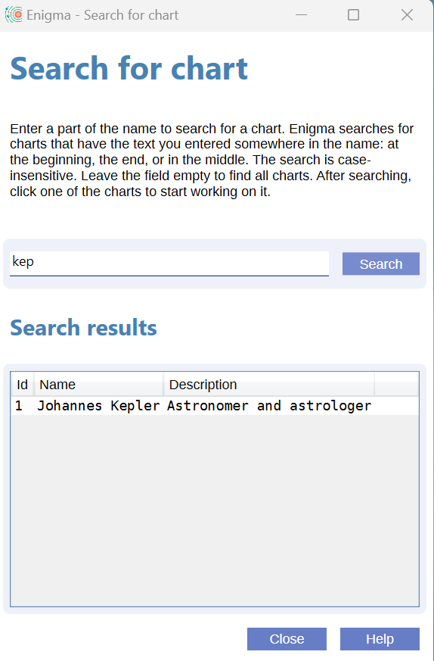
Click the button Search or the menu item Charts -> Search for chart, to retrieve a chart from the database.

In the windows Search for chart you can enter a part of the name and click the button Search. The database will return all charts that have the search term somewhere in the name. To find the chart for Johannes Kepler, you can enter ‘kep’ but also ‘hann’. There is no difference between uppercase and lowercase.
To see all charts, leave the search item blank and click Search.
Add the chart you want to see to the overview by clicking it in the Search results.

Deleting a chart

To delete the selected chart from the database, click the button Delete or select the menu item Charts -> Delete chart. Enigma will show a pop-up with the name of the chart it will delete and a confirmation pop-up after deletion.
If you delete a chart, it remains visible in the Charts folder.
So if you want to check a chart but not save it in the database, just calculate it and click Delete. You can still work on the chart as long as you do not close the Charts window.

Analysis

Chart wheel

To show the wheel for a selected chart, click the button Wheel or select the menu-item Charts-> Show Wheel.
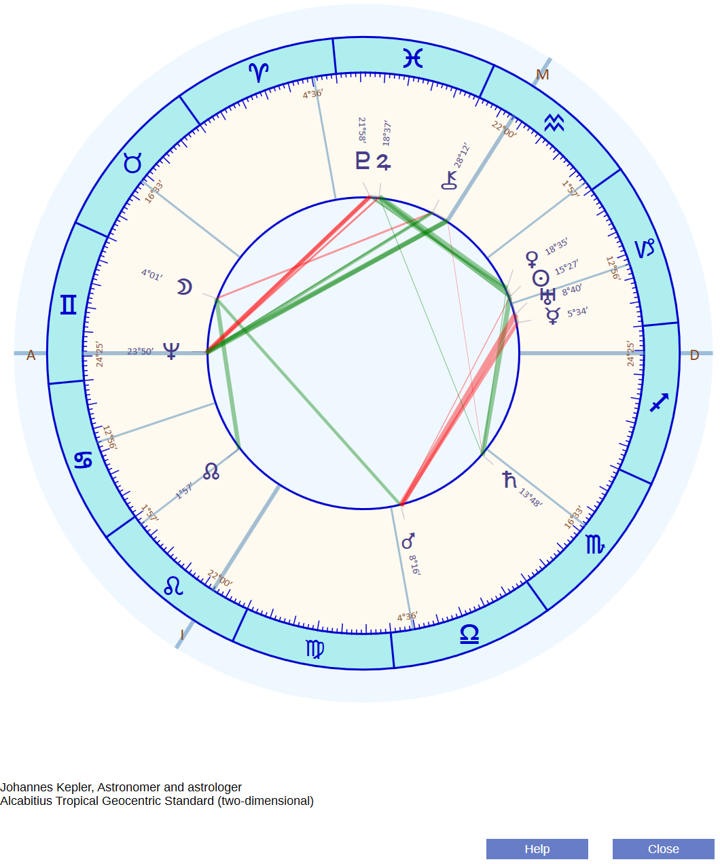
At the left bottom of the window, you will find the name for the chart and the most important selections in the configuration.

You can resize the chart by enlarging the window. Positions, glyphs and lines will resize accordingly.

Overview of positions

To show all relevant positions for a selected chart, you can click the button Positions or select the menu-option Charts - Show Positions.

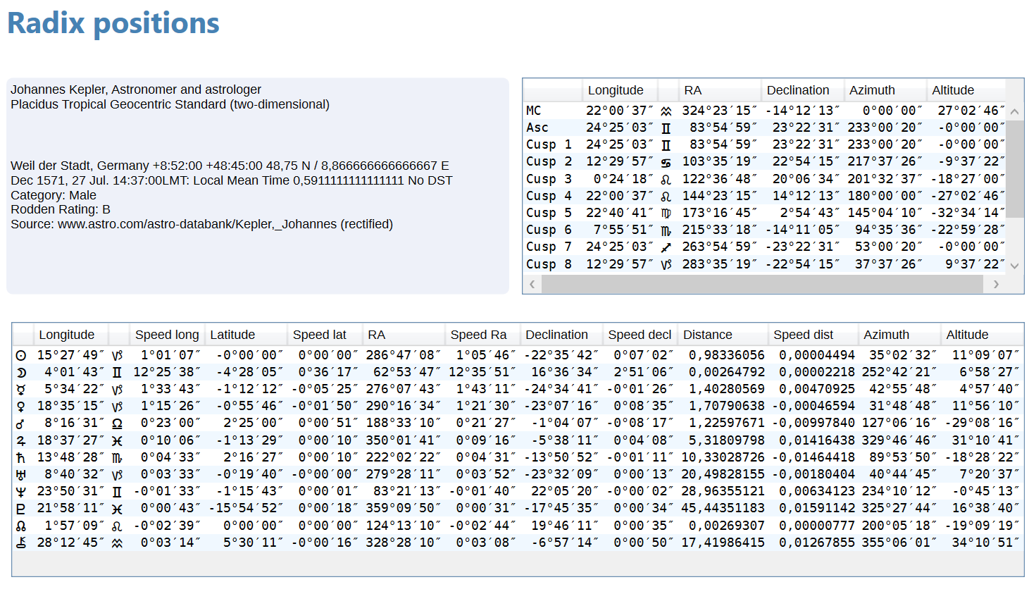

In the rectangle at the top left, Enigma shows the relevant data for the selected chart. The top right table shows the positions of the houses, including MC and Ascendant. If selected in the configuration, this table also shows the data for the Vertex and Eastpoint.
The bottom table shows the positions of planets and other points.

In the tables, Enigma uses the following data:
- Longitude: The ecliptical position as commonly used in the chart.
- Speed long: The daily speed in longitude. A negative value is retrograde.
- Latitude: the deviation from the ecliptic.
- Speed latitude: The daily change of the latitude. Positive if the direction is north, negative for south.
- RA: The Right Ascension, the position measured at the equator. Enigma uses degrees and not hours for Right Ascension.
- Speed RA: the daily speed in Right Ascension.
- Declination: the deviation from the equator.
- Speed decl: the daily change in declination. Positive if the direction is north, negative for south.
- Distance: the distance from Earth or from the Sun (in heliocentric charts), measured in AU (Astronomical units, the mean distance between Earth and Sun). The astronomical term is Radius Vector.
- Speed dist: the daily change in the distance. Positive if the distance increases, otherwise negative.
- Azimuth: the position at the horizon, starting with 0 degrees at the south point and running from south to west, north, east and south again.
- Altitude: the height compared to the horizon. Positive for positions above the horizon, and negative for positions below the horizon.

Enigma calculates no speed for houses nor for horizontal coordinates (azimuth and altitude).

You can resize the window and, if there is insufficient space, scroll the data horizontally and vertically

Aspects

If you calculated or retrieved a chart, you can select the menu option Analysis - Aspects to see the aspects of this chart.

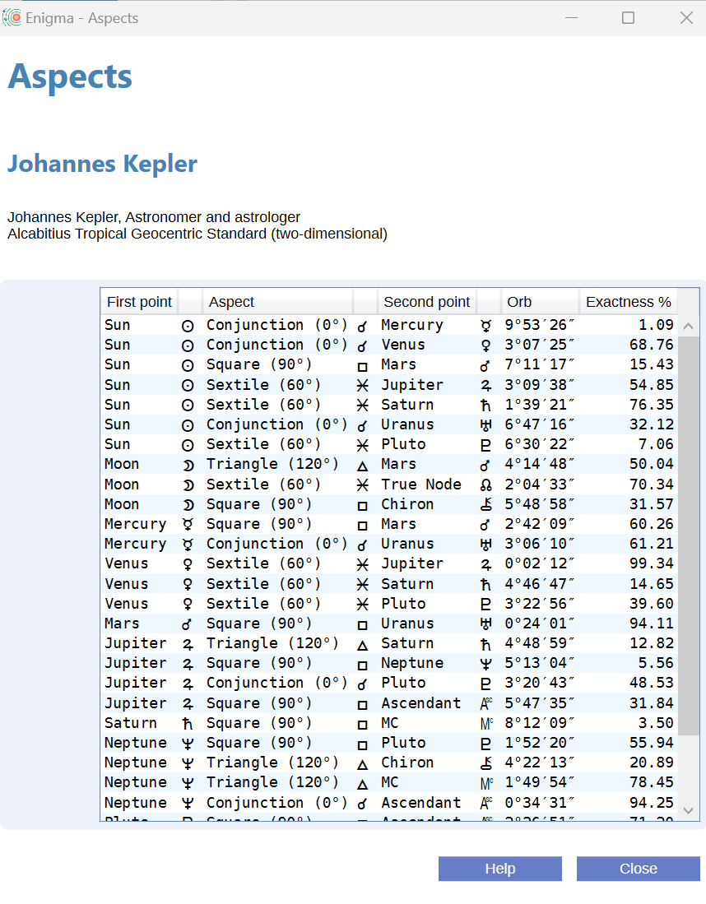
In the table, you will see the name and the glyph for both planets that form the aspect. Enigma also shows the name and glyph for the aspect, the actual orb, and a percentage for the exactness of the orb. If an aspect is almost exact, the percentage will be close to 100%. An example of an exact aspect is the sextile between Venus and Jupiter. The orb is just over 2 minutes of arc and the percentage is above 99%. Enigma calculates the maximum orb using the base orb and percentages in the configuration.

Midpoints

To show the midpoints for a selected chart, select the menu option Analysis - Midpoints.

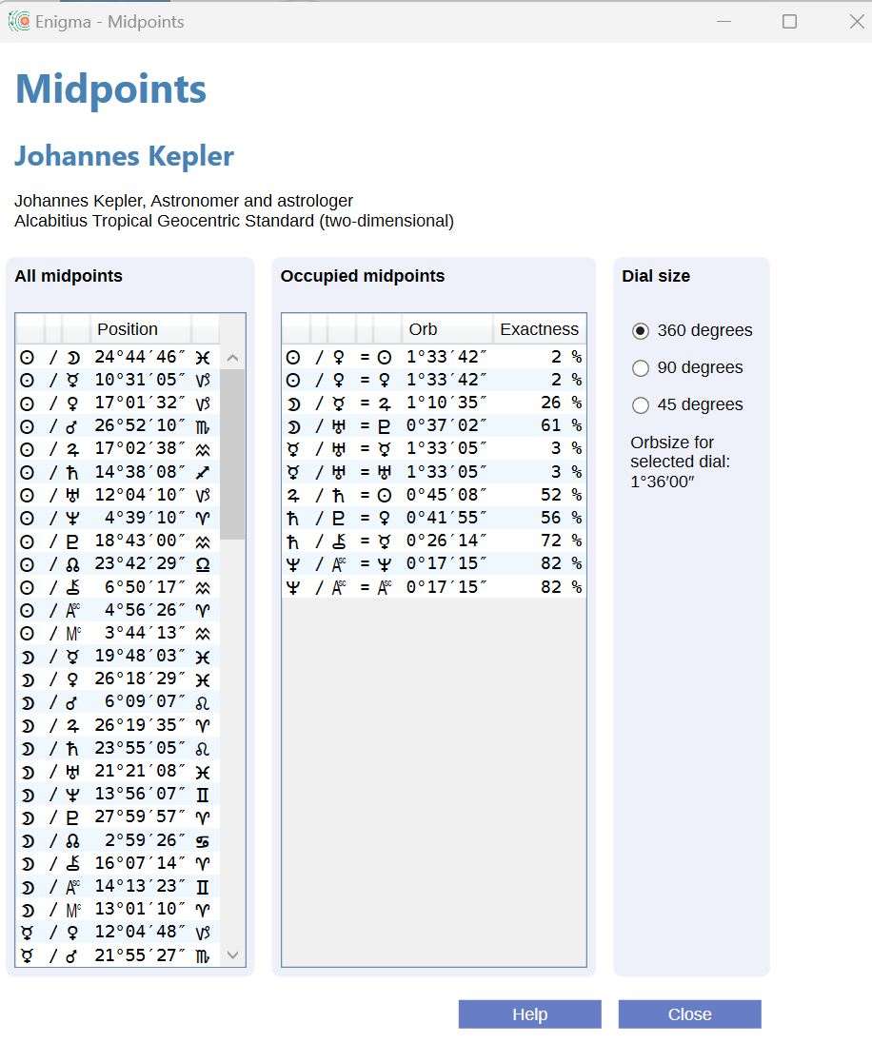
This window comprises two tables. The left table contains a list of all midpoints, regardless if they are occupied, or not. The table to the right shows occupied midpoints for a specific dial.
Both tables will contain only celestial points that you selected in the configuration.
For the Occupied midpoints, you will also see the actual orb and a percentage for the exactness of the midpoint. The higher the percentage, the smaller the orb.
Default, Enigma uses a dial of 360 degrees. You can change the dial with the radio buttons to the right of the two tables. Currently, there is support for the dials for 360 degrees, 90 degrees and 45 degrees. The orb is according to the configuration and the same for all dials.
After changing the selection of the dial, the content of the table with Occupied midpoints will automatically update.

Harmonics

To calculate harmonics for a selected chart, select the menu-option Analysis - Harmonics.
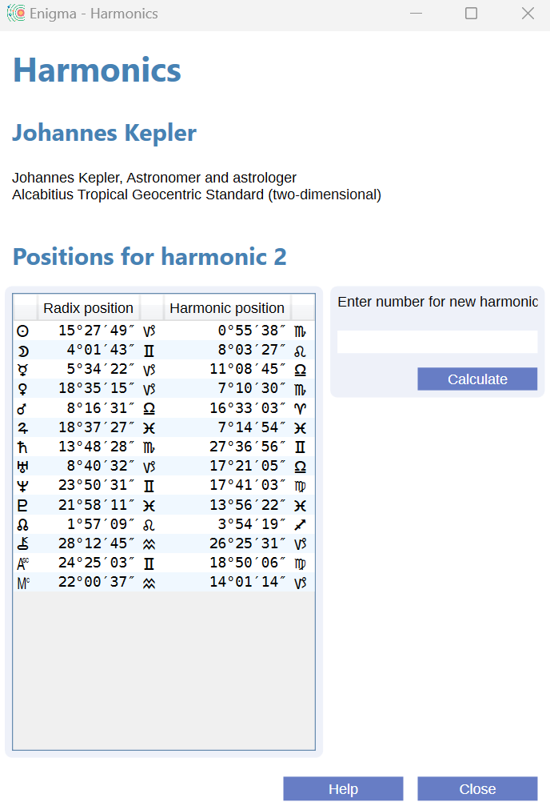
The table contains both the radix positions and the harmonic positions for all celestial points that you selected in the configuration, and additionally for the MC and the Ascendant.
Initially, Enigma calculates the 2nd harmonic. To change the harmonic, enter a number underneath the label Enter number for new harmonic and click the button Calculate.
After clicking this button, the content of the table with harmonics will automatically update.
Enigma also supports fractional harmonics: harmonics for non-integer numbers. You can enter a fractional number the same way as an integer number. Use the decimal separator (dot or comma) that you normally use on your computer.
Enigma shows the effective harmonic shown on top of the table with positions.

Research

To perform research in Enigma, you need to create a data file. For each research that you want to perform, you need to create a project. This project uses one of the imported data files. You can define several projects for the same data file.
A project automatically creates a JSON file with the data for the charts in the data file. JSON is a specific format that is easy to use by computers. Enigma also constructs data for a control group.

Within a project, you can perform several tests. Each test will use the data as entered and the control group as created.
If you run a test, Enigma will show the results, typically a table with counted results. The program saves these results also to disk.
Enigma also saves intermittent results to disk.

Currently, you can use 6 simple tests. More tests will follow, both for radix analysis and for progressions.

Using data files

Research requires data. In the future, Enigma will support multiple formats for data but currently it supports only one standard format. You will find a specification of this format in the Appendix: Format for data files.
An example file with 42 Painters and drawers is available via download: https://radixpro.com/enigma

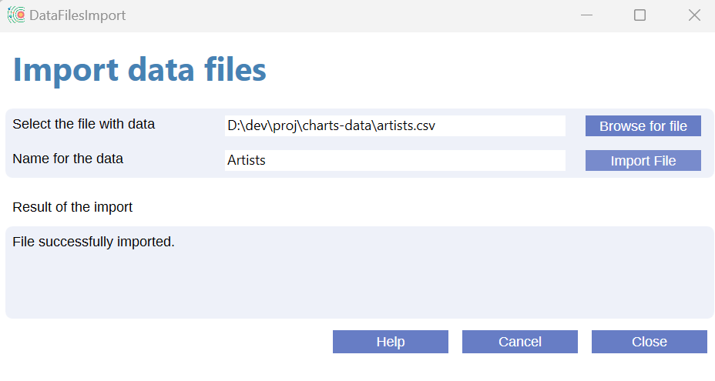
Import data
To import data, you need to select a file in the correct csv format and define a unique name for the data. Enigma uses this name to define the data in research projects.
In the menu, select Data -> Import data

To select your data file, click the button Browse for file. This will open a standard window to find and select a file. The selected file will show in the field after 'Select the file with data'.
Enter a name for the data and click the button Import file.
If you did not enter all required information, or if you used a name for the data that already exists, you will get a pop-up window with an explanation of what is wrong.
If no errors occurred, the program shows a success message underneath Result of the import.
You can check for lines that contain errors in the file c:\enigma_ar\data\errors.txt .
After a successful import, you can either perform another import or click the button Close.
If you change your mind and want to skip the import, click the button Cancel.

Overview of imported data files
For an overview of already imported data files, select Data -> Overview Datafiles in the menu.

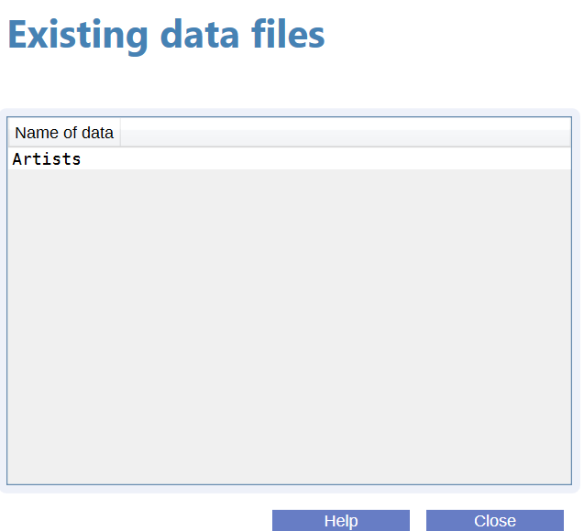

Working with projects

Before you can create a project, Enigma must have access to a data file. If you did not yet import a data file, please do so now. See the previous paragraph.

The Research window shows an overview of available projects. To create a new project, click the button New or select the option Research Projects -> Add new project in the menu.

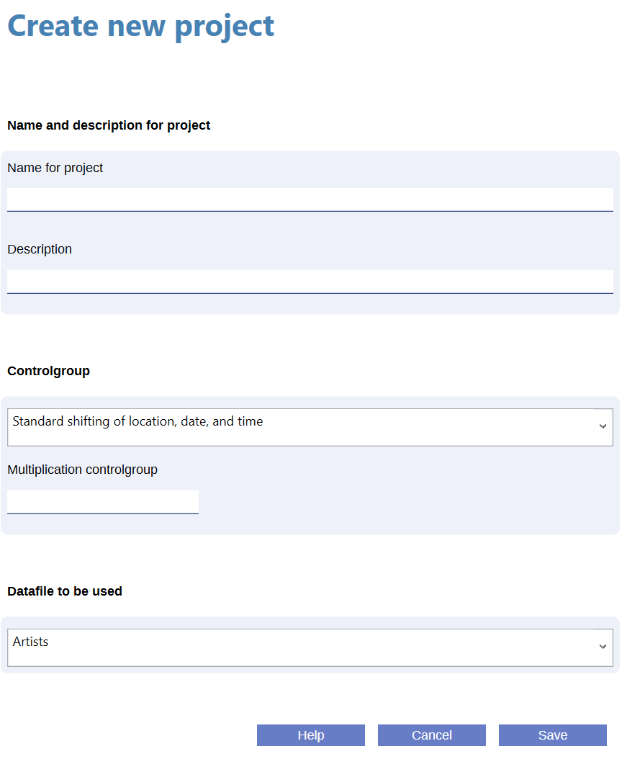
Give a unique name to the project and add a description. For the Control group, you can currently only select Standard shifting of location, date, and time.
Enter a multiplication factor for the control group. If you do not want to multiplicate the control group, just enter ‘1’. The maximum multiplication is 10.
Finally, select a data file and click the button Save.
Enigma will check your input and mark any incorrect input fields with a yellow color. If there are no errors, it creates a folder structure for this project, copies the data file and generates a control file. If during this process an error occurs, you will receive a pop up. Otherwise you will receive a confirmation pop-up. After closing this pop-up, you will return to the main window.

Performing tests

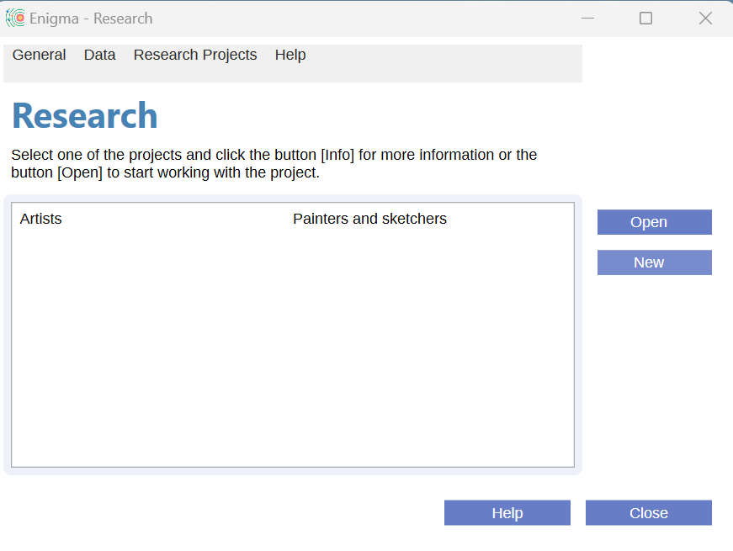
If you imported a data file and created a project, Enigma shows the project(s) in the Research window.
Select the project you want to use, and click the button Open to select a test.

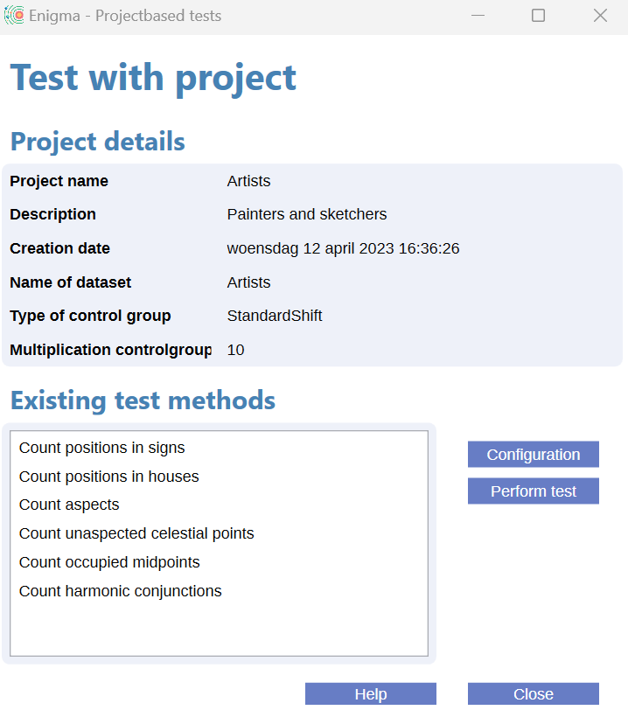
The window Test with project will open. In the upper half of this window, you will see details about the current project, including the dataset that the current project uses, and the type of control group.
The bottom half of the window shows the available test methods. You can perform a method, using the data set for this project, by selecting it in the list and clicking the button Perform test. In subsequent windows, Enigma will ask for more details. The type of details will depend on the type of the selected test.
Please note that the program limits your options to the definitions in the configuration. If you did not include a specific celestial body or aspect in the configuration, you cannot use it in your test. And orbs in the configuration remain active. If you want to check, or change, the configuration, you can click the button Configuration. This will open the standard window to define a configuration and you can change this. After closing this window, the new configuration will be immediately active.

Starting a test
Select one of the available test methods and click the button Perform test.
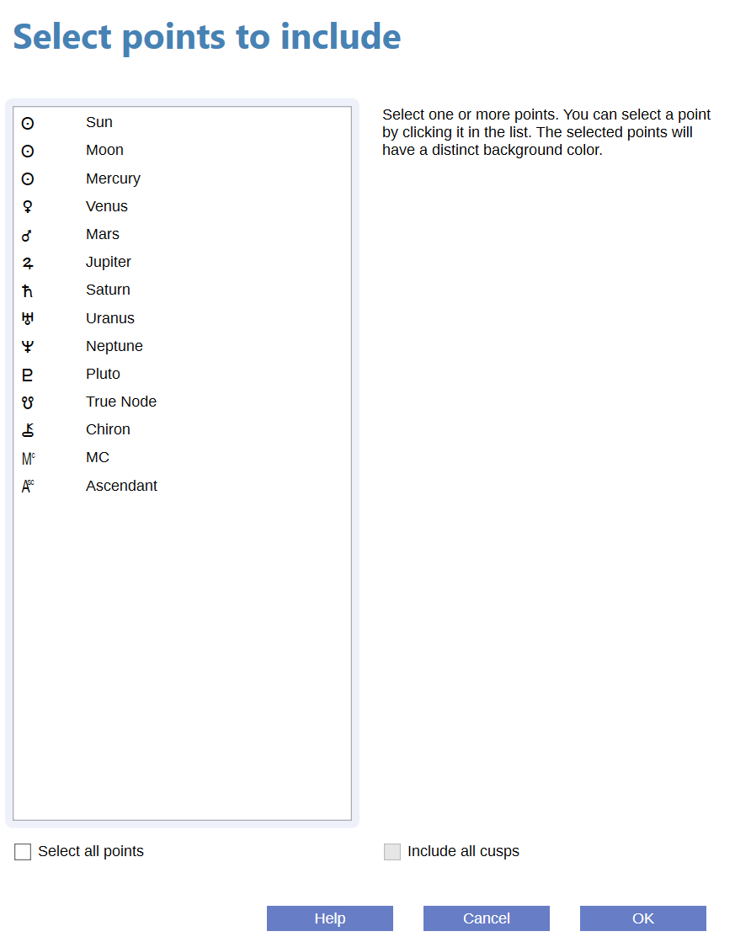
For each test, you will need to define the points to include in the test. The window shows all points in a list. Points that are not selected in the current configuration do not show.
If you are missing a point, you need to redefine the configuration: click the button Cancel to close this window and return to the overview of tests, where you can also open the configuration window.
You can select one or more points by clicking them. Deselect a point by clicking again. You can select/deselect all points by clicking the checkbox Select all points.
With the checkbox Include all cusps, you can include all cusps, but this option is only available for specific types of research. Please note that you can select Ascendant and MC also for quadrant systems. Be aware of this effect.
Click the button OK to start the calculations.

Additional info
Some types of tests require additional information.
For midpoints, you need to define the type of dial and the orb
For harmonic conjunctions, you need to enter the harmonic number and also the orb.
For orbs, the maximum total size is 9°59'. However, such a large orb probably makes little sense.

Research results

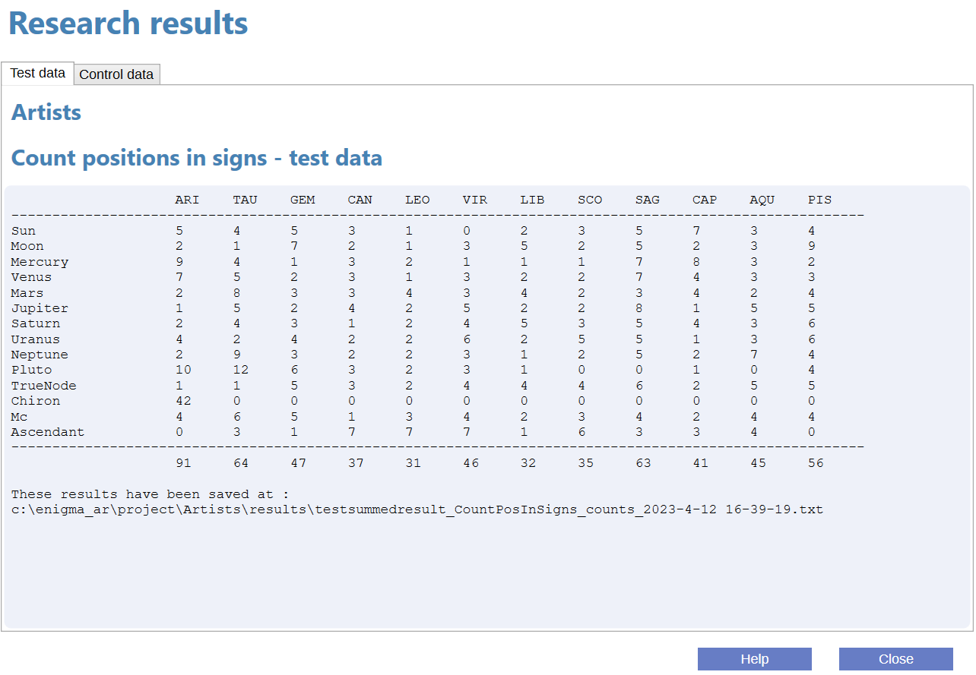
Enigma shows the results of the test in tabular format. Of course, these results depend on the type of test that you performed. You will see two tabs, one for Test data and one for Control data. Each of these tabs shows the result of the respective counting.
The program automatically saves all results to disk. At the bottom of the window, you will find the location of the files for test data and for control data.

Appendix

House systems

Enigma supports the following house systems:

- Placidus is based on the proportional time that the point of the house cusp has traveled. Cusp 11 for instance, should have traveled 1/3 of the time it is above the horizon.
- Koch, also called Birthplace Houses or GOH, divides the time for daily movement of the MC and calculates the ascendant for each time.
- Porphyri trisects the longitudes of the quadrants that are formed by MC, Ascendant, IC and Descendant.
- Regiomontanus divides the equator in equal parts and draws great circles through the division points that intersect the ecliptic.
- Campanus divides the celestial globe into equal parts by drawing great circles from north to south. These circles intersect the ecliptic.
- Alcabitius is comparable to Porphyri, but it trisects the quadrants of the equator.
- The Topocentric system constructs and divides a cone that represents the rotation of the earth.
- Krusinski is comparable to Campanus but it divides the celestial globe looking from points that are perpendicular to the ascendant-descendant.
- APC (Ascendant Parallel Circle) divides a small circle through the ascendant and parallel to the equator and projects the results to the ecliptic, looking from the north to the south. Cusps of this system are not oppositional.
- Morin divides the equator and draws great circles to the poles of the ecliptic. MC and ascendant are not equal to cusps 10 and 1, and the results do not change if the geographic latitude changes.
- The Whole sign system uses the sign on the ascendant as the first house, and then subsequent signs as houses 2, etc. MC and ascendant will not be equal with cusp 10 and 1.
- Equal from Ascendant calculates houses of 30 degrees, starting from the ascendant. The MC is not equal to cusp 10.
- Equal from MC also calculates houses of 30 degrees, but starts with the MC. The ascendant is not equal to cusp 1.
- Equal from 0 Aries considers the houses to be equal to the signs and starts the first house with the sign Aries. MC and ascendant will not be equal with cusp 10 and 1.
- Vehlow is comparable with Equal from Ascendant, but it starts 15 degrees before the ascendant. MC and ascendant will not be equal with cusp 10 and 1.
- Axial Rotation (also called Zariel) divides the equator in 12 equal parts, starting from the right ascension of the MC. Position circles from the north and south and perpendicular to the equator, define the cusps. The ascendant is not equal to cusp 1. The results do not change because of geographic latitude.
- The Horizon system (also called Zenith system) divides the horizon in equal parts, starting in the east. It defines the cusps by drawing great circles, perpendicular to the horizon. Cusp 1 is not equal to the ascendant, cusp 7 is the Vertex.
- Carter divides the equator into 12 equal parts, starting with the right ascension of the ascendant. It defines the cusps by converting the positions in right ascension to longitude. The MC is not equal to cusp 10.
- Gauquelin has the same approach as Placidus, but counts 36 houses and uses a clockwise direction.
- The SunShine system by Bob Makranski trisects the semi arcs of the Sun and defines the cusps by drawing great circles from north to south and through the division points.
- SunShine (Treindl) has the same approach as the SunShine system with a slightly different approach by Alois Treindl.
- Pullen (sinusoidal delta), an approach by Walter Pullen that is comparable to Porphyri. Pullen bases the size of the succeeding houses 2, 5, 8 and 11 on a sine-wave, such that the size of the succeeding houses reflects the relative size of the quadrants.
- Pullen (sinusoidal ratio) is an improvement on Pullen (sinusoidal delta).
- Sripati, as Porphyri, but with the cusps as midpoint between the last and the current house.

In future releases of Enigma, I will add many more house systems but this has a low priority. I will realize this only after the publishing of release 1.0.

Ayanamsha’s

Enigma supports an extensive set of Ayanamsha’s.
The most important ones are:

- Fagan, as proposed by Cyril Fagan and Ronald Bradley.
- Lahiri, official standard in India.
- DeLuce, based on the supposed birth date of Jesus.
- Raman, the ayanamsha according to B. V. Raman
- Krishnamurti, proposed by K.S. Krishnamurti, assumes that the ayanamsha was zero in 291 CE, probably at the date of the equinox.
- Djwhal Kuhl, assumes that the age of Aquarius starts in 2117.
- Huber. The mean ayanamsha as found in Babylonian texts and calculated by the historian Peter Huber.
- Galactic Center 0 Sag, Dieter Koch proposes to put the Galactic Center at 0 degrees Sagittarius.
- True Chitrapaksha starts at 180 degrees from the longitude of Spica.
- Galactic Center (Brand). Rafael Gil Brand proposes to start with the Galactic Center and defines this as the golden section between 0 degrees Scorpio and zero degrees Aquarius.
- Galactic Center 0 Cap. David Cochrane puts the Galactic Center at 0 degrees Capricorn.

For more information, check the documentation of the Swiss Ephemeris at https://www.astro.com/swisseph/swisseph.htm , chapter 2.8 Sidereal Ephemerides for Astrology.

Observer positions

Enigma supports three observer positions. An observer position is the location of a (fictive) observer that registers the positions of the celestial bodies.

You can select one of the following observer positions:
- Geocentric: the observer is in the center of the earth. A somewhat unlikely position, but it is the de facto standard in astrology.
- Topocentric: the observer stands firmly on the earth crest. This is the only position that is physically possible. The positions of the celestial bodies will differ slightly from the geocentric position because of the effect of parallax. It will affect the Moon (up to about a degree) most. The other celestial bodies will differ only a few arc seconds or less.
- Heliocentric: Enigma calculates the positions as seen from the Sun. The positions of the houses, Sun, Moon, lunar nodes and lunar apsides (Black Moon) are not available, but the Earth is.

Projection to the ecliptic

We calculate the ecliptical position of a celestial body by projecting this body to the ecliptic, using an arc that is perpendicular to the ecliptic.
There is one exception to this rule. The Dutch School of Ram calculates the positions with an arc that is oblique to the ecliptic and runs from the north point to the south point. The effect is that it will correctly place the planets in the houses; it solves the latitude problem. The consequence is that the ecliptical positions of planets with higher latitude, typically Moon and Pluto, will fluctuate during the day significantly.
If you want to use the techniques of the School of Ram, you can select in the configuration Oblique Longitude as Type of projection to the ecliptic. In all other cases, select Standard (two-dimensional).

Planets and other celestial points

Enigma will always calculate the classical planets (Sun up to Saturn), MC and Ascendant. All other points are optional.
You can add many other points to the calculation:
- Modern planets: Uranus, Neptune and Pluto. (I’ll call Pluto a planet).
- Mundane points: Vertex and Eastpoint.
- Arabic parts: Pars Fortunae, both with and without sect.
- Mathematical points: Mean Node and True Node, the vernal point (Zero Aries) and three calculations for the apogee of the Moon: Mean, Corrected and Interpolated. The corrected version is according to the most recent lunar theories. I will add the apogee according to Duval in release 0.3 (approximated calculation by Cees Jansen).
- Centaurs: Chiron, Nessus and Pholus.
- Plutoids: Huya, Varuna, Ixion, Quaoar, Haumea, Eris, Sedna, Orcus and Makemake.
- Planetoids: Ceres, Pallas, Juno, Vesta, Hygieia and Astraea.
- Hypothetical points and planets:
  - Uranian: Cupido, Hades, Zeus and Kronos (according to Alfred witte). Apollon, Ademetos, Vulcanus and Poseidon (according to Friedrich Sieggrün).
  - School of Ram: Persephone, Hermes and Demeter.
  - Transpluto, also called Isis, as described by Theodor Landscheidt.
  - Carteret: Vulcanus and Perpsephone, as proposed by Jean Carteret, become available in Enigma release 0.3.

Supported periods for calculations

Enigma can calculate all planets and most other points for a period of almost 30000 years. For some celestial bodies, this period is shorter. Astronomers do not have enough data to calculate these celestial bodies for all periods. If Enigma cannot calculate a point for a specific date, it will omit this point.

Overview supported periods

Celestial points | From | Until
Sun, Moon and planets and all points not in the other rows of this table | -12999/08/02 | 16799/12/30
Chiron | 0675/01/01 | 4650/01/01
Pholus | -2958/01/01 | 7308/12/30
Nessus, Huya, Ixion, Orcus,  Varuna, MakeMake, Haumea, Quaoar, Eris, Sedna | -3000/03/18 | 2998/08/239591/05/23
Ceres, Vesta | -12999/08/02 | 9591/05/23

Defining orbs

Orbs for aspects

An orb for an aspect can depend on many factors. Enigma takes two of these factors into account: the points that form an aspect and the aspect itself.

In the configuration, you define a base orb (Configuration, tab general, Base orb for aspects). The base orb is the maximum orb that is possible.

Also in the configuration, you define an orb percentage for each point in the chart. If you want to use the full orb, you enter 100, and for a smaller orb, a smaller percentage. You will probably use a large percentage for fast moving points and a smaller percentage for slower moving points.
To check if an aspect is within orb, Enigma combines the percentages of both points that form the aspect. It choses the highest value. The idea is that the speed of the fastest point defines the orb.
An example:
The Moon will have a large orb as it moves fast. Pluto will have a small orb. If the percentage of the Moon is 100% and the percentage for Pluto is 50%, you do not want the mean value of 75% as the speed of the Moon is defining the exactness of the aspect.

Aspects also have an orb percentage that you define in the configuration.
The effective orb is the percentage of the point with the highest percentage, combined with the percentage of the aspect.

Some examples, using a base-orb of 10 degrees:

Sun: 100%, Neptune 50% —> 100% for the points.
Conjunction: 100%, effective orb 100% of 10 degrees is 10 degrees.

Uranus: 50%, Eris 40% —> 50% for the points.
Semi-quintile: 30%, effective orb 15% of 10 degrees is 1.5 degree.

Orbs for midpoints

In version 0.1, Enigma supports a configurable base orb for midpoints. In version 0.3, it will be possible to define different orbs for different midpoint dials.

Orbs in research

If you perform a test with harmonics, you can enter the orb that you want to use in your research.

In other research projects, you use the orbs as defined in the configuration.

Format for data-files

Enigma 0.1 supports only one type of data-file.
Version 0.2 will add support for data from the Gauquelin archives and data for progressions.

You can create your own data-file using the csv format (Comma Separated Values). This is a simple text file with one line per chart. You need to separate the different values with a comma. Make sure you use a real text-editor and not Word, LibreOffice Text or another word processor. Examples of a text-editor: NotePad (available in Windows), Notepad++ (more powerful, download it for free from: https://notepad-plus-plus.org/).

An example of the first lines of a data-file:

Id,Name,longitude,latitude,date,cal,time,zone,dst
107, Leonardo da Vinci, 10:55:0:E, 43:47:0:N, 1452/4/14, J, 21:40, 0.7277778, 0
108, Albrecht Dürer, 11:04:0:E, 49:27:0:N, 1471/5/21, J, 11:00, 0.7377778, 0
109, Michelangelo Buonarotti, 11:59:0:E, 43:39:0:N, 1475/3/6, J, 1:45, 0.7988888, 0

You can copy the first line. Do not skip it, as Enigma will always skip this first line automatically.
The lines starting with 107, 108 and 109 contain the real data.
Each line contains 9 fields that correspond to the labels used in the first line:
- Id, a unique identifier. It can be a number or other identification.
- Name. A description for the chart. The name, or a code, if you would like to keep the data anonymous.
- Latitude. Geographical latitude in the format dd:mm:ss:D. For dd enter the degrees (use 1 or 2 positions), for mm the minutes and for ss the seconds. Replace D with ‘E’ for eastern longitude or ‘W’ for western longitude. Use colons between all items.
- Longitude. Geographical longitude in almost the same format as for Latitude: ddd:mm:ss. For dd enter the degrees (use 1, 2 or 3 positions), for mm the minutes and for ss the seconds. Replace D with ‘N’ for northern latitude or ‘S’ for southern latitude.
- Date. Birthdate, or date for an event in the format yyyy/mm/dd. For yyyy enter the year, for mm the month and for dd the date. Use a forward slash between all items.
- Cal. The calendar. For most charts, this will be Gregorian: use the character ‘G’. If the time reckoning was according to the Julian Calendar, use ‘J’.
- Time. Time for the birth or for an event. Use the format hh:mm:ss or hh:mm. For hh enter the hour, for mm the minutes and for ss the seconds. Seconds are optional. Use colons between all items.
- Zone. Enter the correction for the time zone. This is a number, possibly with a fraction. This does not depnd on the locality of your computer: always use a dot between integer part and fraction.
- DST. Shows if daylight saving time applies. Use 0 for no DST and 1 for DST.

Save your data-file, preferably with the extension .csv at a location of your liking. You can import the data-file in Enigma. If one or more charts are using a wrong format, Enigma will recognize this and create a report with the offending lines at c:\enigma_ar\data\errors.txt.

Example file
You can download an example file from https://radixpro.com/enigma/. This file contains the data of 42 visual artists.

Using Excel or Libre Office

You can use a spreadsheet to create a data file. Spreadsheets can read csv files, so you can try it with the example file mentioned above.
Make sure that you use a comma as a separator and do not use quotes.

Result files

If you perform a test, Enigma will create several result files. You can find these files in the folder c:\enigma_ar\project\[projectname]\results .
Replace [projectname] with the name you used for the project.

Counts

The most important file is a text file that shows the counts for the performed test. This file has the same content as the result window that Enigma shows after performing a test.
The name is [type]summedresult_[testmethod]_counts_[date and time].text
- Replace [type] with test (for the test data) or control for the control data.
- Replace [testmethod] with the name of the method.
- Replace date and time with a representation of the actual date and time (during the test).
An example of results for testdata for the method CountOccupiedMidpoints:
Testsummedresult_CountOccupiedMidpoints_counts_2023-4-16 11-52-29

Positions

You can check the positions for the calculated charts. Enigma stores these positions in a JSON file, a verbose format, but it is readable for both humans and computers.
The name of the file is [type]dataresult_[testmethod]_positions_[date and time].json
Use the same replacements as described for the Counts file.
Please note that this file contains over 1000 lines per chart, you might not want to print it. The file contains the same information as given in the window with calculated positions. Each chart in the file starts with the positions, followed by name and other information about the chart.

Folder structure

The application itself is by default in the folder C:\Program Files (x86)\Enigma Astrology Research, unless you defined another folder during installation.
In the folder where you installed Enigma is a sub-folder doc.
In this folder, you will find the User Manual, the Release Notes and the Roadmap for Enigma.

For data, Enigma uses a separate folder structure. These folders do not exist after install; Enigma creates them the first time you use the application.
The folder structure is as follows:

C:\enigma_ar
\data
\ [dataname] (multiple folders)
\csv
\json
\database
\export
\logs
\project
\[projectname] (multiple folders]
\results

In enigma_ar you will find the file enigmaconfig.json. This file contains the configuration for Enigma. Please do not edit this file, but use Enigma itself to change the configuration. If you remove this file, Enigma automatically creates a new default configuration.
The folder data contains the imported data files. All data files have a sub-folder with the name you defined for the data. In the folder structure, this is [dataname]. These folders have two sub-folders: csv and json. They contain respectively a copy of the imported file and the conversion to JSON format.
In database Enigma maintains a database with data for charts. It creates this database after the first calculation of a chart.
The folder export is for future use.
Enigma saves log files in the folder logs. Each day you use Enigma, it creates a new log file. If the number of log files is larger than 31, the program deletes the oldest log file.
The folder project contains sub-folders for each project you create. It uses the names for the projects. In the folder structure, you see [projectname] as placeholder for these names. This folder contains jsonfiles for the definition of the project, the test data and the control data.
The sub-folder results contains the results of the different texts.

Control groups

If you create a project, Enigma will automatically add control groups.

Currently, Enigma supports one type of control group: Standard shifting of location, date, and time.

Enigma creates the control group by collecting all different parts of date, time, and location. It randomly combines these parts to new combinations.

Charts in a control group obviously do not describe real living persons or real existing situations. But they have a comparable distribution in data, time and location. This means that the control group reflects any artifacts, astronomically or demographically, that exist in the test data. A remarkable result in the test data should not show in the control group. If it does, it will probably be because of an artifact.

Optionally, you can multiply the number of combinations to create a larger control group. The maximum supported multiplication is 10.

For the control group type Standard shifting of location, date, and time, Enigma uses the following algorithm:
- Make separate collections of the following items:
  - year
  - month
  - date
  - hour
  - minute
  - second
  - indications for the use of DST
  - time zones
  - geographic longitudes
  - geographic latitudes
- Sort the values for the days from large to small.
- Shuffle all other items using a randomizer.
- Repeat for each item in the test data, optionally multiplied with a factor to increase the control group:
  - Combine the elements at the top of each collection into a new chart. Make sure that only applicable months combine with dates larger than 28.
  - Remove the used elements.

More information

Documentation
- Release notes. The release notes contain a description of the added functionality per release.
- Roadmap. The roadmap shows the planned functionality for coming releases.
- Developers manual. If you’re a programmer, you might be interested in the Developers Manual.

You can download all documentation from https://radixpro.com/enigma/

Facebook group
You can join the Facebook group for Enigma:
https://www.facebook.com/groups/246475509388734/

Websites
The website for Enigma - and for other astrological stuff - is https://radixpro.com (English), use https://radixpro.org for technical information for programmers.

Mailing list
You can subscribe to a mailing list. I only send mails for new releases of Enigma.
To subscribe, send a mail with the subject ‘subscribe’ to enigma@radixpro.org
To stop a subscription, send ‘unsubscribe’ to the same address.

Source code
Enigma is open source. You can use the source in your own open source projects but not in closed source projects. Your program does not have to be free to use the Enigma source, but it has to be open source.
Please look at the copyright details in the main folder of the source.
The source is available via github:
https://github.com/jankampherbeek/EnigmaSuite

Support
No software is without errors. I heavily tested Enigma, but that does not guarantee the absence of errors.
If you encounter an error, you can contact me at the email address enigma@radixpro.org

